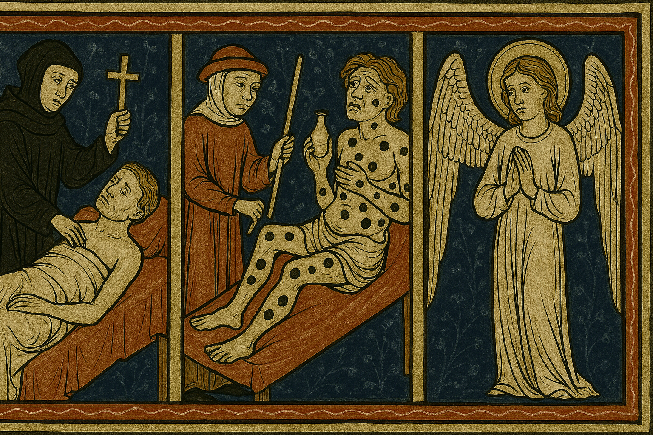
A triptych denoting the rapid progression of the plague called the Black Death. Illustration by Master Max AI. Copyright St Saviour’s Church, Lewisham, 2025.

THE CATHOLIC CHURCH IN THE 14TH CENTURY:
A TIMELINE OF KEY EVENTS

The 14th century (1301-1400) was a period of significant upheaval and change across the globe. Key events include the Great Famine, the Black Death, the Hundred Years' War, and various political and social shifts in Europe, Asia, and the Middle East. It also marked a period of immense upheaval in the Catholic Church. The papacy’s relocation to Avignon between 1309 and 1377, sometimes called the Babylonian Captivity, and which contributed to the Western Schism (1378-1417), significantly diminished the office’s prestige and authority as it increasingly came under the influence of the French monarchy. Even so, the century saw a surge in reported in mystical experiences and writings, particularly in Germany and the Low Countries. The 14th century in theology was marked by significant change. The Western Schism, the decline of the Crusades, and the emergence of early reformers such as John Wycliffe began to undermine the Catholic Church and set the scene for wholesale reformation movements in subsequent centuries. However, both the controversial Dominican friar Meister Eckhart, whose writings emphasised the unknowable nature of God, excepting through personal experience, and the mystic and reformer, St Catherine of Siena, played a role in trying to maintain unity.
Below is a timeline highlighting some of the highlights of the period, which affected the Catholic Church and the principal theologians and popes of the day. They are and will be covered in more detail in subsequent articles and discussions.

1305: William Wallace executed in London.
1307: Knights Templar destroyed.
1308: Duns Scotus (c.1265–1308) dies. A Scottish Franciscan friar and theologian, Scotus engaged in detailed philosophical and theological arguments, particularly concerning the nature of universals and the Immaculate Conception of Mary.
1309-1376: The Avignon Papacy, with the papacy located in Avignon, France, rather than Rome. The move, cynically referred to as the Babylonian Captivity by Florentine poet Petrarch, created tension and criticism within the Church. Among the popes who resided in Avignon, subsequent Catholic historiography grants legitimacy to these:
Pope Clement V: 1305–1314. He moved the papal office to Avignon on 9th March, 1309. A Frenchman, Pope Clement V is remembered for suppressing the order of the Knights Templar and allowing the execution of many of its members.
Pope John XXII: 1316–1334. The pope is best known for centralising church administration. The Pope came into direct conflict with Franciscan Spirituals called Fioretti or Little Flowers of St. Francis, who made direct comparisons between Francis and his followers and Christ and his Apostles. Spiritual Franciscans also felt that the Testament of St. Francis, written by Francis on his deathbed, which prescribed poverty and mendicancy for the Franciscan order, was to be taken literally. After Francis' death, the principal Franciscan Order gradually modified its rules on poverty so that the Order as a whole could possess material goods. The Spiritual Franciscans were vehemently opposed to this modification. Because of their continued criticism of the papacy and the Order, they were condemned as a heretical sect. the pope also expanded papal control over the appointment of bishops, and, against the wishes of French Emperor Louis IV, upheld papal authority over imperial elections. Pope Benedict XII: 1334–1342: Pope Benedict XII was the least convinced of the Avignon popes of the efficacy of having the papal office outside Rome. Unable relocate to the Vatican, or even Bologna (another of his preferences) he settled on enlarging and beautifying the great palace at Avignon. His bull Benedictus Deus, stated that souls may attain the "fullness of the beatific vision" before the Last Judgment. His office was in virtually constant conflict with Emperor Louis IV and he failed to bring the Holy Roman Empire back under papal dominance. He died 25 April 1342 and was buried in Avignon.
Pope Clement VI: 1342–1352: Roger steadfastly resisted temporal encroachments on the Church's ecclesiastical jurisdiction. and, as pope Clement VI, entrenched French dominance of the Church and opened its coffers to enhance the regal splendour of the Papacy. He recruited composers and music theorists for his court, including figures associated with the then-innovative Ars Nova style of France and the Low Countries (todays Netherlands and northern Belgium).
Pope Innocent VI: 1352–1362: Another French pope. He majored in civil law at the University of Toulouse and later took holy orders, rising to become a bishop in 1338. He appointed as a cardinal four years later by Pope Clement VI, who he followed as pope. Pope Innocent was a reformer, encouraging bishops and cardinals to actually live in their sees, and tried to reform the papal curia. Like his predecessors, he railed against the growing power of the French monarchy, which was still in control of the Holy Roman Empire. He forgave and released the Roman tribune Cola di Rienzo, who had been excommunicated by Clement for heresy because of his rebellion against the Holy Roman Empire. The pope encouraged Rienzo in 1353 to assist Cardinal Albornoz, vicar general of the Papal States, in restoring papal power at Rome, hoping to make possible a return of the papacy from Avignon to Rome. Rienzo, however, was killed on October 8th, 1354, in a Roman riot, and Innocent died before he could fulfill his dream of returning to Rome.
Pope Urban V: 1362–1370: (in Rome 1367–1370; returned to Avignon 1370). Pope Urban V was a member of the Order of Saint Benedict and is the only Avignon pope to be beatified. He was known for his efforts to restore peace within the Church. He was elected pope in 1362 while on diplomatic business, even though he was not a cardinal. His reign was blessed by his peacekeeping activity between the French and Italian kings, the founding of many universities, his zeal for the crusades and his decision to return the papacy to Rome and end the Avignon exile of the popes. However, the breakout of war between England and France forced him to return to Avignon on a peacekeeping mission, whereupon he died. He was buried in Marseille and his tomb reportedly became the site of miracles. Pious, Pope Urban lived simply, retained his Benedictine habit and was renowned for his virtue, unusual in a church and a political system that was corrupt and scandal-riven.
Pope Gregory XI: 1370–1378: The last of the official popes in Avignon. Persuaded by Catherine of Siena, he left Avignon to return to Rome on 13 September 1376. He was the nephew of Pope Clement VI. Gregory XI did not survive much longer after his move to Rome. He died on 27 March 1378 aged about 48. Pope Urban VI, an Italian, was elected to the papacy after his death. However, Pope Gregory XI’s decision to move the papacy back to Rome ultimately led to the Western Schism and the rise of the so-called Antipopes. Most of Europe supported Clement VII (now considered an antipope) as the true pope. Subsequently, the Western Schism created by the selection of rival popes forced Europe into a dilemma of papal allegiance for the next thirty years, until the Church achieved unity once more following the Council of Constance, convened between 1414 and 1418 and the election of Pope Martin V.
1314: Battle of Bannockburn: Scottish victory in the First War of Scottish Independence.
1315-1317: The Great Famine, a period of widespread crop failure and starvation.
1328: End of the First War of Scottish Independence.
1328: Meister Eckhart (c.1260–1328) dies. A German Dominican friar and mystic, Eckhart's writings explored themes of union with God and the nature of the divine ground. His teachings, while influential, also sparked controversy and were later condemned by the Church. However, in recent years, he has enjoyed something of a rehabilitation, with Popes in the later part of the 20th century, repeatedly referring to his work, while the Dominican order has done much to rehabilitate his theological works.
1337: The Hundred Years' War begins, a conflict between England and France over territorial claims and the French throne.
1346: Battle of Crécy, an early English victory in the Hundred Years' War.
1347: William of Ockham (c.1287–1347) dies. A pivotal figure in late medieval philosophy and theology, Ockham is best known for Ockham's Razor (nowadays more commonly referred to as Occam’s Razor), the principle of parsimony, which suggests that the simplest explanation is usually the best. His nominalist philosophy challenged the prevailing Aristotelian realism and influenced subsequent theological and philosophical thought.
1347-1351: The Black Death, a devastating pandemic of bubonic plague, begins to spread across Europe. The plague ravaged Europe, leading to widespread death and societal disruption. This event significantly impacted religious thought, with some interpreting it as divine punishment and others questioning the Church's ability to offer solace and protection. The second pandemic of the Black Death, which was particularly deadly.
1348: University of Prague founded.
1348-1350: Peak of the Black Death in Europe, killing an estimated 30-60% of the population.
1358: The Italian Augustinian friar Gregory of Rimini (c. 1300-1358) dies. Gregory is known for his work on grace, free will, and the sacraments. He emphasised the importance of divine grace in salvation and challenged some of the prevailing views on human nature.
1378-1417: The Western Schism, where multiple individuals claimed to be the legitimate Pope, further weakening the authority of the papacy and causing division within the Church. The two Avignon-based antipopes were:
Clement VII: 1378–1394. Pope Clement VII was almost universally acknowledged as the true pope, however, politics ensured he would not rule from the Vatican and modern history casts him in the mould of antipope.
Benedict XIII: 1394–1423 (expelled from Avignon in 1403)
Benedict XIII was succeeded by three antipopes, who had little or no public following, and were not resident at Avignon:
Clement VIII: 1423–1429 recognized by the Crown of Aragon; abdicated
Benedict XIV: 1424–1429 or 1430
Benedict XIV: 1430?–1437
Parties within the Catholic Church were divided in their allegiance among the various claimants to the office of pope. The Council of Constance finally resolved the controversy in 1417 when the election of Pope Martin V was accepted by all Catholic bishops.
1380: Caterina di Jacopo di Benincasa (1347– 1380), known as St Catherine of Siena dies. One of the patron saints of Italy, and recognised as a doctor of the church. Caterina Jacopo di Benincasa, the daughter of a wealthy cloth dyer, was born and raised in Siena, The house where Catherine grew up still exists. Catherine wanted from an early age to devote herself to God, against the will of her parents. She joined the mantellates, a group of pious women, primarily widows, informally devoted to Dominican spirituality. Energetic, clever and erudite, Caterina enjoyed influence with Pope Gregory XI and reportedly played a role in his 1376 decision to leave Avignon and re-establish the papal office in the Vatican. The Pope then sent Catherine to negotiate peace with the Florentine Republic. After Pope Gregory XI's death in March 1378 and the conclusion of peace with Florence in the same year, Caterina returned to Siena. She dictated to secretaries her set of spiritual treatises, The Dialogue of Divine Providence. However, her life of seclusion was short-lived. The Great Schism of the West, which fractured the office of the papacy for almost nigh on 30 years, forced Caterina’s return to Rome. From her office there, she sent numerous letters to princes and cardinals to promote obedience to Pope Urban VI and to defend what she called the "vessel of the Church". She died at the end of April 1380, exhausted by her rigorous fasting and overwork. Catherine of Siena was canonised in 1461 by Pope Pius II.
1381: The Peasants' Revolt in England was a significant social uprising, partly fired by religious grievances and discontent with the Church and social hierarchy. It also challenged
taxation and feudal restrictions.
1381: John of Ruysbroeck (1293-1381) dies. A Flemish mystic, Ruysbroeck focused on the contemplative life and the ascent to union with God. His writings emphasized the importance of both active and contemplative spiritual practices.
1384: Death of John Wycliffe, an English theologian and early Church reformer. Wycliffe's views on scripture, sacraments, and papal authority anticipated some of the ideas that would later be central to the Protestant Reformation. He also spurred the rise of Lollardy, a popular heresy in England influenced by Wycliffe's teachings, challenging the Church's doctrines and practices.

